System Design and System Requirement Specification.

1. A Brief Summary of the System.
The system I’m building for this project is a standard hybrid IT environment, some services on-premises, and some services that can be run or recovered in the cloud. The primary objective is to improve availability and resiliency by eliminating critical single points of failure and by making recovery easier when something does fail.
One thing I want to avoid in this design is assuming that redundancy alone means high availability. Two application servers, for example, are not very useful if they both depend on the same storage system, network connection, or authentication service. The architecture therefore looks at the dependencies between the different parts of the infrastructure, not only at the individual components.
The environment is representative rather than based on a real production network. It allows me to work with realistic infrastructure components and failure scenarios, without using real IP addresses, server names, credentials, or other sensitive information.

2. The Architecture Proposed.
The architecture is divided into two main areas, an on-premises primary site and a cloud environment that can also serve as a disaster recovery site. Users can connect from the office, remotely or from a branch. Their traffic passes through the network and security layer before reaching the services they are authorized to use.
In the primary site the main infrastructure is broken down into compute, core services, storage and monitoring. The compute area consists of virtual machines, applications and other workloads. The core capabilities are services such as identity, authentication, DNS and databases. Storage provides the data needed by these systems.
The cloud side follows a similar structure, although it does not mean that every component at the primary site has to be duplicated. The resources maintained there depend on the importance of the service and its recovery requirements. Data that is needed for recovery can be replicated in real time or at scheduled intervals.
Monitoring covers both sides of the environment. This is important because redundant infrastructure is not sufficient if failure is not detected quickly. Backup is something else separate from replication. Replication can help keep services up, and backups provide a way to get data back if it’s deleted, corrupted or otherwise unavailable.
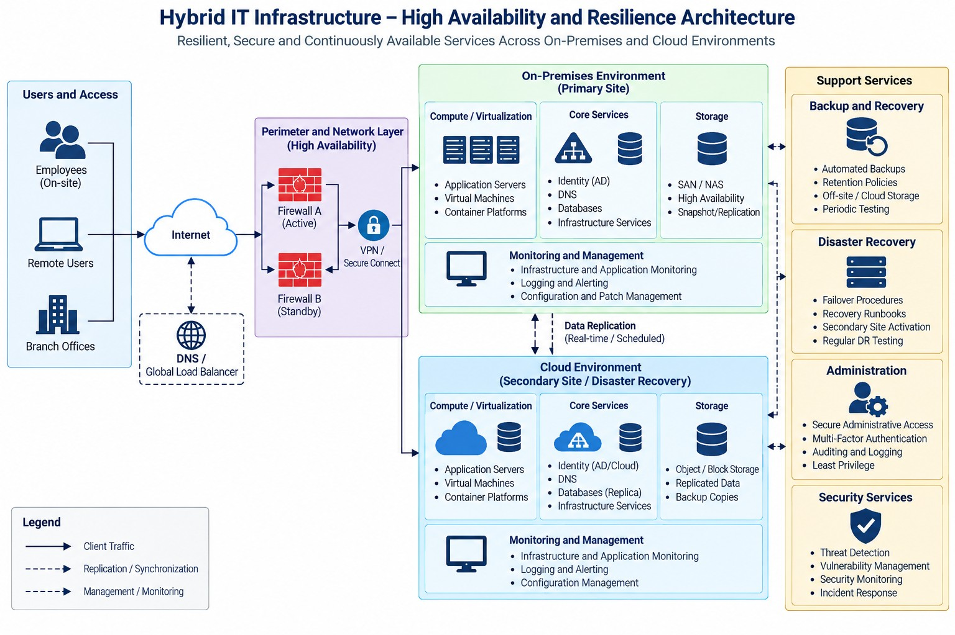
Figure 1 shows the proposed architecture. The design is divided into two main areas: an on-premises primary site and a cloud environment that can also provide disaster recovery capabilities. Users may connect from the office, remotely, or from a branch location. Their traffic passes through the network and security layer before reaching the services they are authorized to use.

3. Modules and Functional Specifications.
I divided the design into logical modules so that the role and dependencies of each part are easier to identify.
User Access module – connections from staff, remote users and branch offices. It takes a user request and credentials, and after authentication and authorization, it grants access to the requested service. Remote connections can use VPN and multi-factor authentication.
The Network and Security module controls how traffic enters, leaves, and moves through the environment. Its input is network traffic and its output is filtered and correctly routed traffic. Redundant firewalls and network paths are used so that one failed device should not isolate the entire environment.
The Compute module hosts applications and infrastructure workloads. Application requests are its main input, while the output is the running service provided to the user. Virtualization and clustering can be used to move or restart workloads when a physical host becomes unavailable.
Storage receives application and system data and provides it to the services that need it. Depending on the type of information, this can include redundant local storage, snapshots, or replication to the secondary environment.
Core Services include identity, authentication, DNS, and other common infrastructure services. This is especially important as they are depended on by many other systems. Losing an authentication or DNS service, for example, could make healthy application servers effectively unavailable.
The Monitoring and Management module collects logs, events, and performance information from the infrastructure. Its main outputs are dashboards, alerts, and information that administrators can use to investigate a problem. Monitoring also provides evidence that can later be used to evaluate how the proposed design behaves during failure scenarios.
The final two areas are Backup and Recovery and Disaster Recovery. Backup creates independent recovery copies of important systems and data. Disaster Recovery uses replicated data, backup copies, secondary resources, and documented procedures to restore services after a larger outage. Recovery procedures also need to be tested; simply having a backup does not demonstrate that a service can actually be restored.

4. Functional Specifications.
According to the architecture, the following are the main functional requirements:
- FR1: The system shall provide secure access for authorized local and remote users.
- FR2: The infrastructure shall host and run the required application and infrastructure services.
- FR3: Critical data shall be stored using resilient storage mechanisms.
- FR4: In case of failure of a single component, identity, authentication and DNS services should still be available.
- FR5: The system shall monitor the health and availability of critical infrastructure elements.
- FR6. Report any major failures or abnormal conditions to administrators.
- FR7. Backups of critical systems and data are taken in accordance with defined retention requirements.
- FR8: There must be secondary resources or documented recovery procedures to recover critical services.
- FR9: Administrative access shall be restricted, authenticated and logged.

5. Non-Functional Requirements.
Availability and reliability are the most important non-functional requirements for this project. Critical services should not rely on one component when a reasonable redundant option exists. At the same time, I do not want to add redundancy everywhere just for the sake of it. The level of protection should depend on how important the component is and what would happen if it failed.
Performance also has to remain acceptable during normal operation and, where possible, after a failure. The design should not introduce a recovery solution that creates a major bottleneck during everyday use.
Scalability is addressed by keeping compute, storage, monitoring, and cloud resources modular. This makes it possible to increase capacity later without redesigning the whole environment.
For usability, the main concern is the administrators who have to operate and recover the infrastructure. Monitoring should generate meaningful alerts and not meaningless noise. Recovery procedures should be simple enough to follow in an outage.
Finally, security is part of the availability design. Administrative access should follow least privilege and use stronger authentication where appropriate. Management activity and important security events should be logged. Backup and recovery systems also need protection, because a recovery solution is of little value if the same incident that affects production can also compromise the backups.

